TopCoder Direct Improve Group Management Assembly Specification

Purpose
TopCoder would like to make some improvements (especially performance) on the group related logic in Cockpit, the purpose of this contest is to identify the performance issue and design a better solution for the changes.

The purpose of this contest is to identify the performance issue with group management and design a better solution, we also want to include some other small enhancements to the group related logic.

Requirements

Improve Performance of the Add Members Functionality

When adding multiple members to a group the performance is poor.
The main reason identified for this is the multiple sequential AJAX calls to searchUser. This call is made to check if the user with given handle actually exists.
An example of such a call is
https://cockpit.cloud.topcoder.com/direct/group/searchUser?_=1389251200154&handle=super
Since these calls are made synchronously and sequentially, this means that if there are 20 users in a group, 20 calls will be made one after another for each user.
Please note that even if there were say 18 existing users and only 2 new have been added, calls will be made for all 20 users.
The following is a screenshot of these requests captured in Chrome's Developer Tools Box.

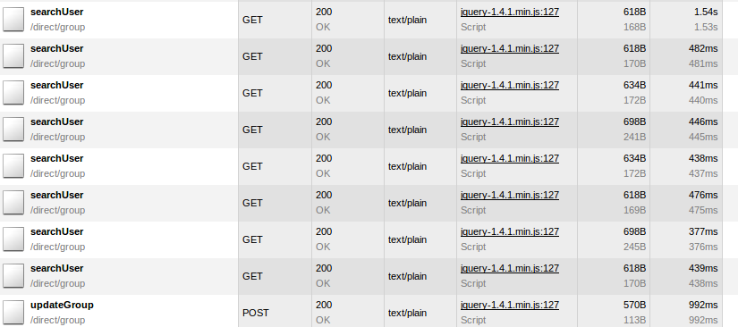
As can be seen from the screenshot, each request takes roughly 500ms on average, so for say 20 users, this process will take 10 seconds. For 60 users, it will take half a minute.

This also explains the “Page Unresponsive” dialogs that users are getting. For example, Firefox's default timeout period for scripts before it shows the “Page Unresponsive” dialog is 10 seconds.
http://kb.mozillazine.org/Dom.max_script_run_time

To fix this issue, instead of making multiple calls to searchUser we will just make one call to a new getUsers endpoint with all the handles passed into the method as parameters. Here are the details:
- Create a new /group/getUsers endpoint which accept multiple parameters of the name handles (so in HTTP terms the parameter is handles[])
The method will match the handles exactly and return the User instances for those handles.
  - In SearchUserAction.java, create a new field
private String handle; to private String[] handles;
Similarly create the getter and the setters.

  - Create a new public method in SearchUserAction called getUsers method. Here simply call groupUserService.getUsersByHandles. Then save the returned List<UserDTO> in the users instance variable.

  - This new method will have to be added to struts.xml as an action. This can be done using:
<action name="getUsers" class="groupSearchUserAction" method="getUsers">

<result name="success" type="json" />

<result name="error" type="json" />

</action>

- A new get_users_by_handles query will be created in informixoltp. It will have one parameter called usernames which will comma separated string of user handles which will be matched exactly. Its implementation will simply be:
select u.user_id, u.handle, e.address
from user u, email e
where handle_lower IN (@usernames@) and e.primary_ind = 1 and e.user_id = u.user_id

- Create a new method in UserService called getUsersByHandles which takes in parameter handles:String[]. Create its implementation in HibernateUserService. (The class is poorly named as it doesn't use Hibernate at all). The implementation will use the new query get_users_by_handles. The query will be passed parameter usernames which will be a comma separated and single quote delimited string of all the handles.
So for example usernames = "'tomek', 'dok', 'ivern'"
The result of the query will be converted into a List<UserDTO>, sorted by user handles and returned.

- Change the code in group.js to pass in multiple handles parameters.

  - Make just one call to check all handles
Currently the problematic code is located at line 664 in the method validateMember. This is the code that makes repeated AJAX calls.
for(var i=0;i<handles.length;i++) {
var exist = checkHandleExist(handles[i]);
if(!exist) {
showErrors('User with handle: ' + handles[i] + ' doesn\'t exist.');
return false;
}
}

The loop should be removed and the call should be changed simply to checkHandlesExist(handles).

  - Modify the checkHandleExists to send all handles to server
The function checkHandleExists should be renamed to checkHandlesExist and it should take handles:array as parameter.
It should make the AJAX call to the group/getUsers endpoint and it should pass multiple handles[] parameters each with one handle.
So for example, for handles = ['dok', 'heffan', 'tomek'] it should pass the parameters as handles[]=dok&handles[]=heffan&handles[]=tomek

In the response, the method will now receive many user objects instead of just one. We will check here that the response contains all users that were passed in the handles parameter. If not, then the user(s) with given handle(s) were not found.

var handlesFound = new Array(handles.length);
for(var i=0;i<handles.length;i++)
for(var j=0;j<result.length;j++)
if (handles[i] == result[j]) {
handlesFound[i] = true; break;
}
//Assembler can make this faster by considering that result will contain array of users which are already sorted by handles. So binary search can be used.

Now handlesFound should consist of all trues, and if not then the handles at the corresponding indices were not found. We should show error in modal.

Notify user of activity on Save Group

When adding multiple members to a group and pressing “Save Group” button, currently there is no indicator that anything is happening until the AJAX calls to check the validity of users are complete.
This should be corrected. On click of Save Group, the button must get disabled and the text should become “Saving...”. In case of failure of either the /group/getUsers or /group/updateGroup AJAX call, the button should re-enabled and text should be restored back to “Save Group” .
Implementation details for this are quite simple and left to developer.

Effect of many billing accounts and projects on save group page

As discussed in http://apps.topcoder.com/forums/?module=Thread&threadID=808344&start=0, the effect of having many billing accounts and projects on performance was tested. 10 billing accounts and 15 projects were used as shown in the screenshot, but there was NO observed change in the performance of the Save Group activity.
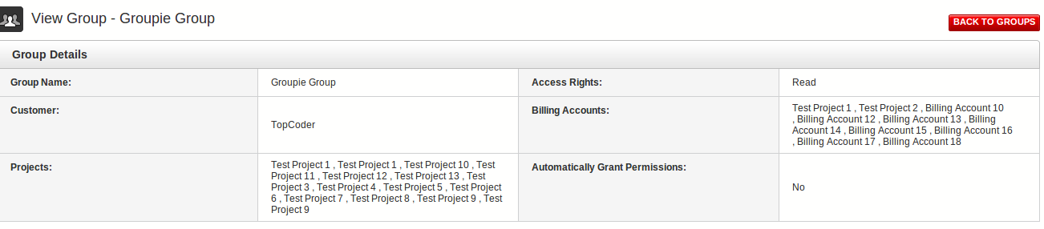

Effect of emails

It is unlikely that sending emails will have any effect on performance, not unless we send thousands of them. SMTP is non-blocking. SMTP Server will just queue the message and return success. SMTP Client does not have to wait till the message is delivered.
If the SMTP Server is taking too long to even acknowledge the message queuing, then that is really something wrong with the SMTP Server. Fixing that should be out of scope.

Sorted Member Handles

On View Group page, we need to show the users of group in ascending order of handle.
We will make change to HelperUtility#fillHandle method. In the last line of the method, we will sort the group.getGroupMembers list using:

Collections.sort( group.getGroupMembers(), new Comparator<GroupMember>() {
public int compare(GroupMember o1, GroupMember o2) {
return o1.getHandle().compareTo(o2.getHandle());
}
public boolean equals(Object other) {
//return true if other is not null
//AND other has type GroupMember
//AND this.handle = other.handle
//else false
}
}

Since the HelperUtility#fillHandle method is also used on the Edit Group page, it will make sure that the users are sorted by handle on that page as well.

Filter on Enter press
We will bind to the enter key on all textboxes used for filtering on the View Groups page.
Simply add the following to group.js

$(“dl.filterUserGroup input”).onkeypress(function(e) {
if (e.which == 13) {
filterItems(false, 1); //Call the filter method
}
});

Group Management Page – Modify display and use of existing users
On the group management page, the textboxes containing existing users should be disabled, so that users cannot make change to them and can just remove them. This is easily accomplished in group.js
$(“#groupMemberTable input[value]”).prop('disabled', true);

Also we need to make sure that when we add users we only send in the new users (and not all user) to the call to /groups/getUsers. This can be achieved by changing the first loop in validateMember method from:

$("#groupMemberTable tbody tr").each(function() {

var inp = $(this).find(".firstColumn input[type='text']");

var handle = inp.val().trim();
...
}

to

$("#groupMemberTable input:not(:disabled)").each(function() {

var handle = $(this).val().trim();
...
}

